Town of Old Orchard Beach For Town use:
1 Portland Ave Date:________________________
Old Orchard Beach ME 04064 Permit #:_D___________________
MBL:________________________
Address:_____________________
Fee Paid:_____________________
Driveway Permit Application Fee: $100
Address For Work Location:______________________________________________________________
Property Owner Name:_________________________________Phone (daytime):__________________
Property Owner Address:_______________________________Email:___________________________
Contractor Name:_____________________________________Phone (daytime):__________________
Contractor Address:___________________________________Email:___________________________
Contractor Business Name:_____________________________
Please check what applies:
- Residential Driveway ___ Number of units using driveway ____
- Commercial Driveway ___
- New Driveway ___
- Existing Driveway ___ Expansion ___ Alteration ___
Minimum Requirements:
A site sketch showing:
a) Location of existing and proposed driveway entrance, including
a. distance from property boundaries
b. distance from adjacent streets
c. street frontage
b) Width and length of existing and proposed driveway
c) Proposed grades if the driveway slope exceeds 5% within twenty feet of the right-of-way
d) Sidewalk, if applicable
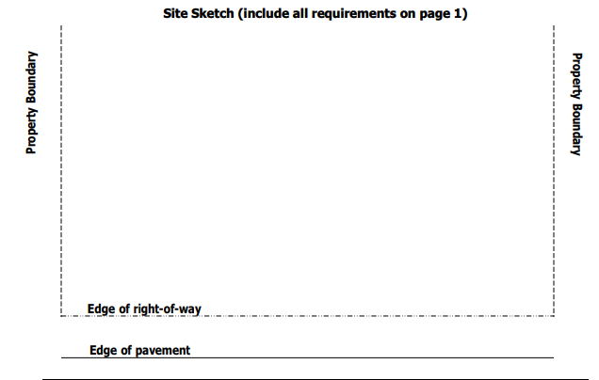
If the project includes excavation anywhere within the limits of the Town right-of-way, inspections must be scheduled through the Department of Public Works as follows: 1. Initial startup; 2. Before fill in of utility (if applicable); 3. Upon completion
As the Applicant/Owner, I hereby agree to the following:
1. To construct driveway entrance(s) in accordance with the requirements set forth by the Town of Old Orchard Beach and any State Agency requirements that may apply.
2. To furnish, install, and maintain drainage structures to maintain drainage across driveway entrance(s).
3. To notify the Code Enforcement Office and Department of Public Works for inspection (when applicable) and upon completion of construction activities.
4. Pay the Driveway Permit fee in the amount of $100 payable to the Town of Old Orchard Beach.
5. Post a $1,000 Bond or Cash/Check payment in escrow with the Public Works Director.
Applicant/Owner Printed Name: _______________________________________
Applicant/Owner Signature: __________________________________________ Date:_______________
************************************************************************************PPermission to construct a driveway at the above-requested location, in accordance with Chapter 78, Article VIII, Division 4, Subdivisions II and III of the Town of Old Orchard Beach Code of Ordinances (attached) has been granted. Applicant must complete work within 1 year of the date of permit approval unless another date is approved by the Department of Public Works.
Director of Public Works or Designee:________________________________ Date:________________
Code Enforcement Officer:_________________________________________ Date:________________

